PART 1.

What would be your arguments for attributing personality to AI systems?

PART 2.

- What are the key differences between a limited partnership and a private limited company in Thai law?

- Explain the process of obtaining a petty patent in Thailand and the type of inventions that can be patented.

- Is registration of copyrighted work an essential requirement for:

  - National protection

  - International protection

Explain:

- What distinguishes a design patent from a trademark, and how would this difference apply to a product like the distinctive shape of Crocs shoes? Provide your explanation.

- Differentiate between a loan for use and a loan for consumption under Thai law and provide examples.

- What legal protections are offered to tenants under Thai hire of property law?

- What is the difference between real contracts and consensual contracts? Provide examples for each

- How does Thai law regulate the formation and governance of public limited companies, and what are the key responsibilities of their directors?

- Explain the principle of "first to file" in the context of patent law in Thailand and its significance for inventors and businesses.

- Under Thai law, what constitutes a trade secret, and what legal measures can be taken to protect it?

- What are the rights of unregistered trademarks under Thai law?

PART 3.

Maple Events Ltd. engages Mr. Arun to oversee the catering and event setup for their corporate clients. Mr. Arun's contract specifies a duration of 100 days, during which he agrees to comply with all operational guidelines and instructions issued by Maple Events. At the end of the 100-day term, Mr. Arun's work has not met Maple Events Ltd.'s standards. As a result, Maple Events decides to outsource Mr. Arun to assist with the operations of one of their client.

(a) What type of contract is in place between Mr. Arun and Maple Events Ltd.?

(b) How could this arrangement be construed as a sale contract with conditions, where Maple Events is considered the seller?

(c) What are the primary differences between a sale contract, an employment contract (hire of services), and a hire of work contract?

4. Khun A signs a contract with Marketing Solutions Co., Ltd. to launch a new marketing campaign for his business. The contract outlines specific goals and timelines for the campaign. However, the person responsible for managing the campaign, Khun B, fails to properly execute the campaign, leading to financial losses and damage to Khun A's business.

Questions:

a) What kind of contract does Khun A have with Marketing Solutions Co., Ltd. and why?

b) What type of contract might Khun B have with Marketing Solutions Co., Ltd.? Explain your reasoning.

c) What are the legal issues in this case?

d) How might the nature of Khun B's contract affect the potential legal outcomes for Marketing Solutions Co., Ltd.?

e) What should Khun A do now and why?

PART 4.

Question 1

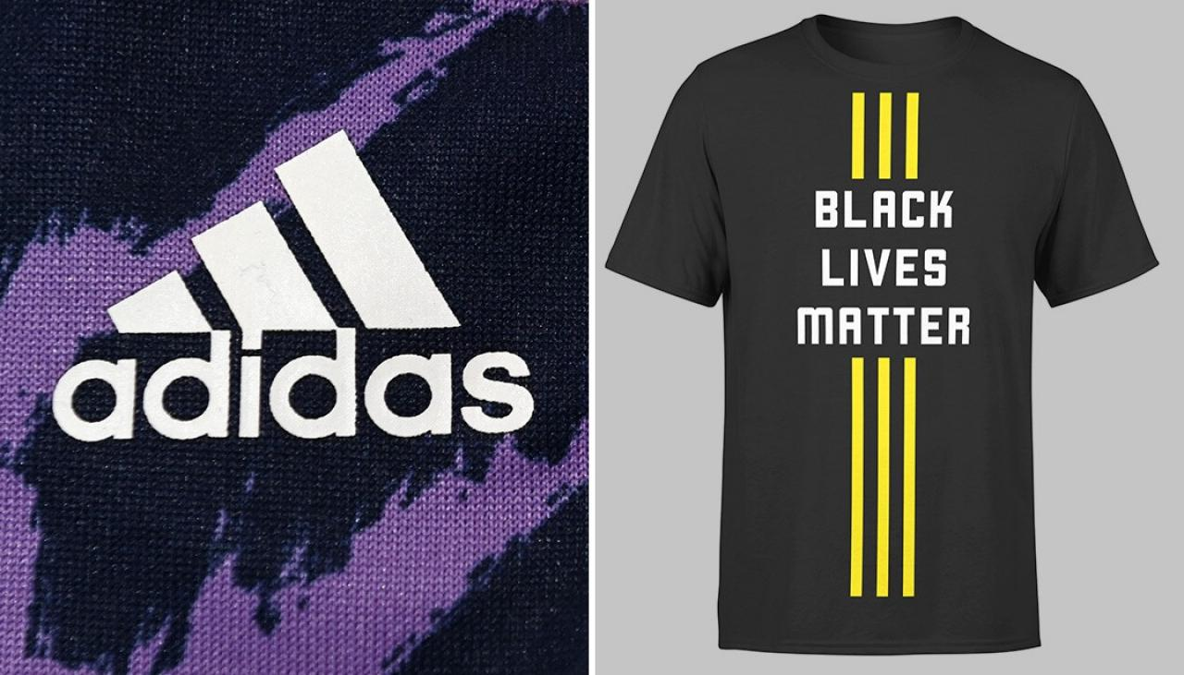

Adidas AG has filed a complaint against the Black Lives Matter Global Network Foundation Inc. for using a trademark with three parallel yellow stripes. Adidas claims that this design is very similar to its famous three-stripe logo and might confuse customers into thinking that the products are related to Adidas. The Trademark Office has given the Black Lives Matter group a deadline to respond to this complaint.

Question 2

2.1 In the 80’s, Michael Jackson devised a novel dance move called “the moonwalk”.

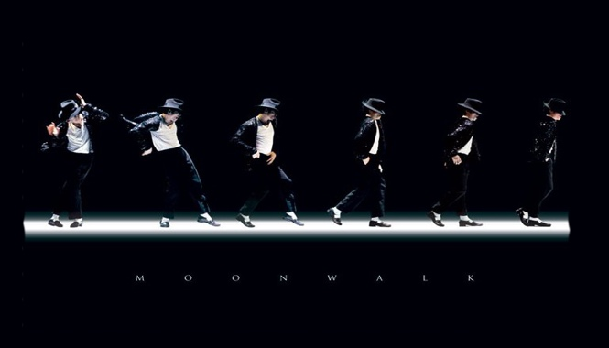
Source: wallpapersafari.com

2.2 In the late 80’s, Michael Jackson devised a dance routine where he leaned forward 45 degrees, giving an impression that he was defying gravity. For doing this, he created a special shoe for giving anti-gravity illusion. The special shoe had a slotted heel which slid onto bolts that protruded from the floor, essentially creating a dovetail joint between the dancer and the stage.
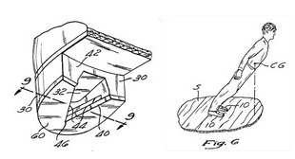

Question 3

  - What will the Thai Trademark Office look at to decide if there is a risk of confusion?

3.2 What could happen if the Thai Trademark Office agrees with Adidas? What if they don't?

Question 4

  - Explain if a single dance move which lasts only few seconds can receive legal protection?

  - Can a full dance of several minutes which is made of a series of movements that are arranged in a unique and original sequence receive legal protection?

  - Discuss different legal strategies which could be used to give effective legal protection to this type of device?

Question 5

In May 2017, Mr. Egg had produced samples of semen prior to undertaking courses of chemotherapy which had the potential to damage his fertility. His intention was that his sperm should later be available for him should he wish to become father. The sperm was frozen and stored by a local private clinic named HappyLife. Before the sperm could be used, it melted and became watery because of the clinic’s failure to maintain the storage facility correctly, and was in consequence destroyed. Mr. Egg claimed that he had suffered damages.

  - Does Mr. Egg have any legal claim against the clinic? Please examine all the legal grounds on which the complaint may be based.
  - Suppose you want to start a private clinic business like HappyLife, which form of business organization would be most appropriate for this type of business and explain the reason for your choice.

Question 6

Please answer all questions:

- Albert found a stone in his yard and took it to Bob, a jeweler, for evaluation. Although Bob knew what the stone was, he told Albert that he wasn't sure as to the nature of the stone, but that he thought it was a topaz. Bob then offered to buy the stone for 5,000 baht and Albert agreed. Later Albert found out the stone was an uncut diamond worth about 50,000 baht. Is this contract valid?

- Ralph sold a motel to Steve by stating that he had paid 2,500,000 baht for it and that his net average annual profit from the business has been 40,000 baht. In reality he paid 1,500,000 baht for the motel and has earned a net average annual profit of only 30,000 baht. Steve made no attempt to verify the statements until after the transaction was completed. Is this contract valid?

- Jill contracted to purchase Kevin's automobile under the belief that she could sell it at a profit to Linda, but after Jill bought the car, she found out that Linda isn't interested in buying it. What can Jill do now?

Question 7. Chai, Teera, and Som are planning to start a business together operating a specialized surgery clinic. This clinic will perform complex surgical procedures requiring advanced medical equipment and highly skilled staff. The nature of their business means they will handle delicate and critical medical operations, where any mistakes could have serious consequences. They need to decide on the most suitable form of business entity to protect their personal assets and manage the high level of responsibility and potential challenges involved. They are considering whether to form a partnership or a company and need to determine which specific type of partnership or company would be the most appropriate for their situation. As their legal advisor,
- Recommend the most suitable form of business entity for Chai, Teera, and Som.
- Discuss whether they should choose a partnership or a company, specifying which particular type of partnership or company is most appropriate for their specialized surgery clinic and explain why.
Question 8. Lek is a shareholder and director of a private limited company called "Tech Innovations Co., Ltd." He owns 30% of the company's shares and is actively involved in its management. Recently, Lek made a decision that benefited his personal interests but caused a loss to the company. Some shareholders are unhappy and question Lek's actions.
- What are Lek's duties and responsibilities as a director of the company?
- What legal remedies are available to the other shareholders?

Question 9. Consider a situation where an initial patent is filed for a groundbreaking genetic editing technology named CRISPR used in one type of organism, such as prokaryotic cells (bacteria). Subsequently, a different patent application is submitted for employing the same technology CRISPR in a different category of organisms, such as eukaryotic cells (human, animal, and plant cells). As a legal advisor, evaluate whether this later application for using the genetic editing technology in eukaryotic cells can be considered patentable in Thailand. What are the patent eligibility criteria under Thai law?
- Does this application meet the patent eligibility criteria ?
- What are the main legal challenges for obtaining the patent on CRISPR applications on eukaryotic cells?

