How to create a Canvas account?

Section1: 1pm-4pm

1. Click on the link: https://canvas.instructure.com/enroll/KR8DDF

2. First enter your mahidol official email (edu or ac.th) then write your full name in following way: First Name and Family Name.

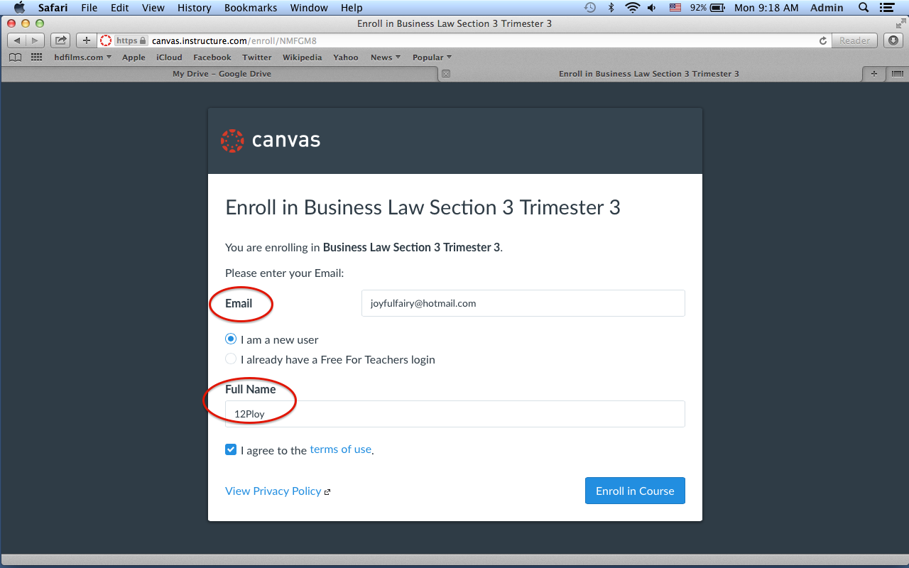

3. After you click on Enroll in Course, the following window will open:

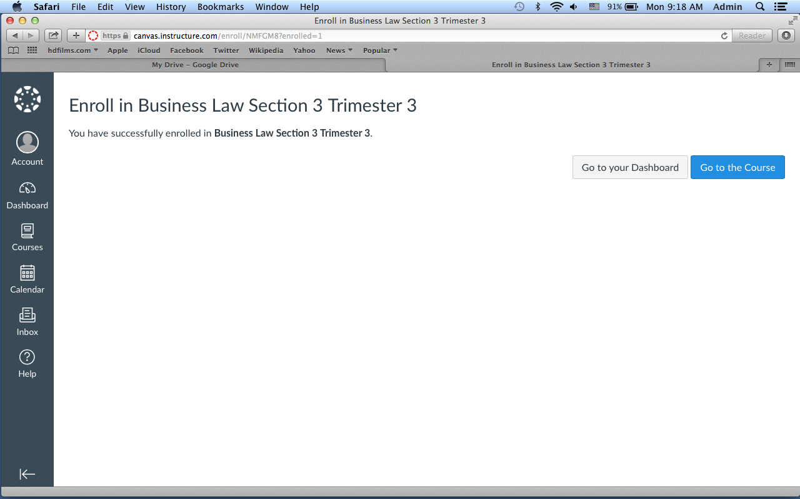

4. After you verify your email address by clicking the link in the email Canvas sent you (make sure to check your spam box), go in Account -> Settings -> Edit Settings -> Time Zone and write Bangkok (+07:00).

